PROJECT

* NAME :REGATIPALLI THARUNKUMAR REDDY
* HALL TICKET NO: 24705A0329
* BRANCH :MECHANICAL
* YEAR :3RD B TECH
* COLLEGE :ANNAMCHARYA INSTITUTE OF TECHNOLOGY & SCIENCE ,RAJAMPET .

PROJECT NAME:

calculate gear ratio’s, speed, torque, efficiency.

Inputs : No: of gears, teeth, input speed and torque

Outputs : Output speed, torque, efficiency.

Libraries : Numpy, matplotlib.

CODE:

# PROJECT

import numpy as np

import matplotlib.pyplot as plt

a=int(input("enter the no:of teeth on driven gear:"))

b=int(input("enter the no:of teeth on driving gear:"))

c=int(input("enter input speed:"))

d=int(input("enter input torque:"))

a=int(input("enter the driven gear speed:"))

b=int(input("enter the driving gear speed:"))

gearratio=a/b

print("Gear ratio:",gearratio)

outputtorque=gearratio*d

print("output torque:",gearratio*d,"kw")

print("efficiency:",outputtorque/d,"%")

OUTPUT:

enter the no:of teeth on driven gear:40

enter the no:of teeth on driving gear:30

enter input speed:3000

enter input torque:300

enter the driven gear speed:3500

enter the driving gear speed:3000

Gear ratio: 1.1666666666666667

output torque: 350.0 kw

efficiency: 1.1666666666666667 %

BY USING MATPLOTLIB:

import matplotlib.pyplot as plt

x=[250,40]

y=[13,40]

plt.plot(x,y)

plt.title("speed vs torque")

plt.xlabel("speed")

plt.ylabel("torque")

plt.show()

OUTPUT:

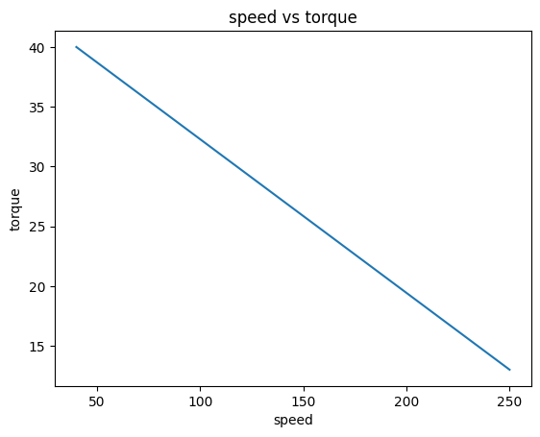

CONCLUSION:

By using the python programming calculation of gear ratio’s, speed, torque, efficiency and graphical representation had been excuted successfully. By doing this project we can obtain the graphical analaysis of the torque and speed effectively.